Anatomy Physiology Prep

CSC 131 Software Engineering

Professor/Sponsor: Doan Nyguen



By:

**Shah Newaz**

**Christopher Simon**

**Marco Campos**

Proposal

Lately, there has been high demand for jobs in the medical field, so we have come up with the idea of creating an application in order to help students prepare with certain courses that are pertained in such majors. Our application will be based on Anatomy Physiology because most, if not all, medical students must take this course in order to introduce them with the basic structures of anatomy.

Application Structure

There will be seven categories incorporated into the application. Each category is involved in certain systems of the human body. Further, each category will have three sub categories that test the user on medical terminology, matching, and the definitions of each of these categories. Each sub category will contain a database of questions, obtained from various sources, such as books and credible websites. There will also be an exam option, in which users will be able to answer questions from all the subcategories contained in each of the anatomy system. The outline below describes how each category is to be organized.

* Skeletal System
* Muscular System
* Integumentary System
* Central Nervous System
* Peripheral and Autonomic Nervous System
* Endocrine System
* Lymphatic and Immune System
* Respiratory System
* Digestive System
* Urinary System
* Reproductive System

Each Category of the systems will have subcategories which include: Medical Terminology, Multiple Choice, Definitions, Exam, and an option to move to the previous menu. Here’s an example of how each category will be displayed for the user on the program console.

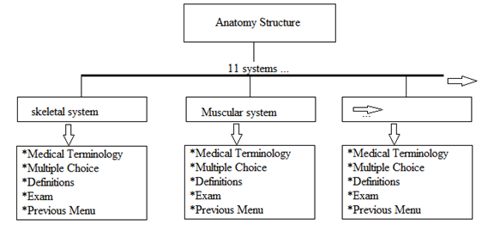

Skeletal System

* Medical Terminology
* Multiple Choice
* Definitions
* Exam
* Previous Menu

When the user enters a subcategory he or she will have the option of how many questions they want to be asked. There will be a random generator which will choose a random question from the database. When the user answers the question, the program will alert the user if they got the answer right. If the user enters the wrong answer, the program will alert the user if they got the answer wrong, and will output the correct answer. Before the next question is asked, the program will generate another random question to be asked, but it will not display the same question twice. When the user has completed the questions in the subcategory, the program will output how many questions the user got right out of how many questions that were asked. Then the program will prompt the user if they can: Take the quiz over, review only the answers he or she got wrong, or the option to move to the previous menu.

Question Database

We will produce a database of questions that we will attain from resources such as textbooks and legitimate websites.

Progress

How will we test the accuracy and the application? This program will be practiced with students currently or has taken this course and will get feedback on how we can improve on how this program will not only be educational, user friendly, and fun to use.

How to organize work load

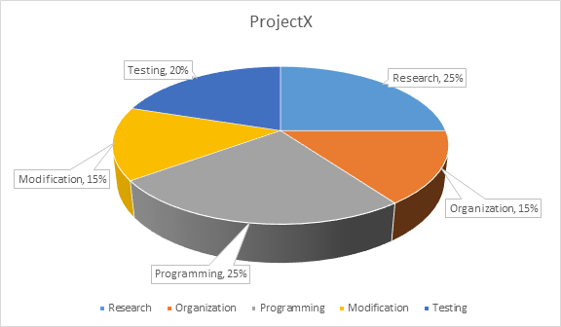

Functionality

Qualitative Property

Deliveries

Future add ons

Other subjects/exams including the MCAT, LSAT, PE tests, and United States Medical Licensing Examination (USMLE)

.

Ability for the user to create their own study exams from other subjects.

User Rankings.

cellphone and portable tablet accessibility

Budget information

This app will be free. Revenue can be generated purely through advertisements and donations.

Our ultimate goals

We believe that students that like to learn, and will use our software not just to pass their classes but to generate desire for further interest in the field they wish to excel in.

Reference Page

Scott, Ann Senisi, and Elizabeth Fong. *Body Structures & Functions*. Australia: Thomson/Delmar Learning, 2004. Print.

Dill, Kathryn. "10 Jobs In High Demand That Require A College Degree." *Forbes*. Forbes Magazine, 1 Dec. 2014. Web. 09 Sept. 2015.

Stockwell, Carly. "Behavioral Science Tops List of Fastest Growing Majors of the past 5 Years." *USA TODAY College*. N.p., 26 Jan. 2015. Web. 09 Sept. 2015.